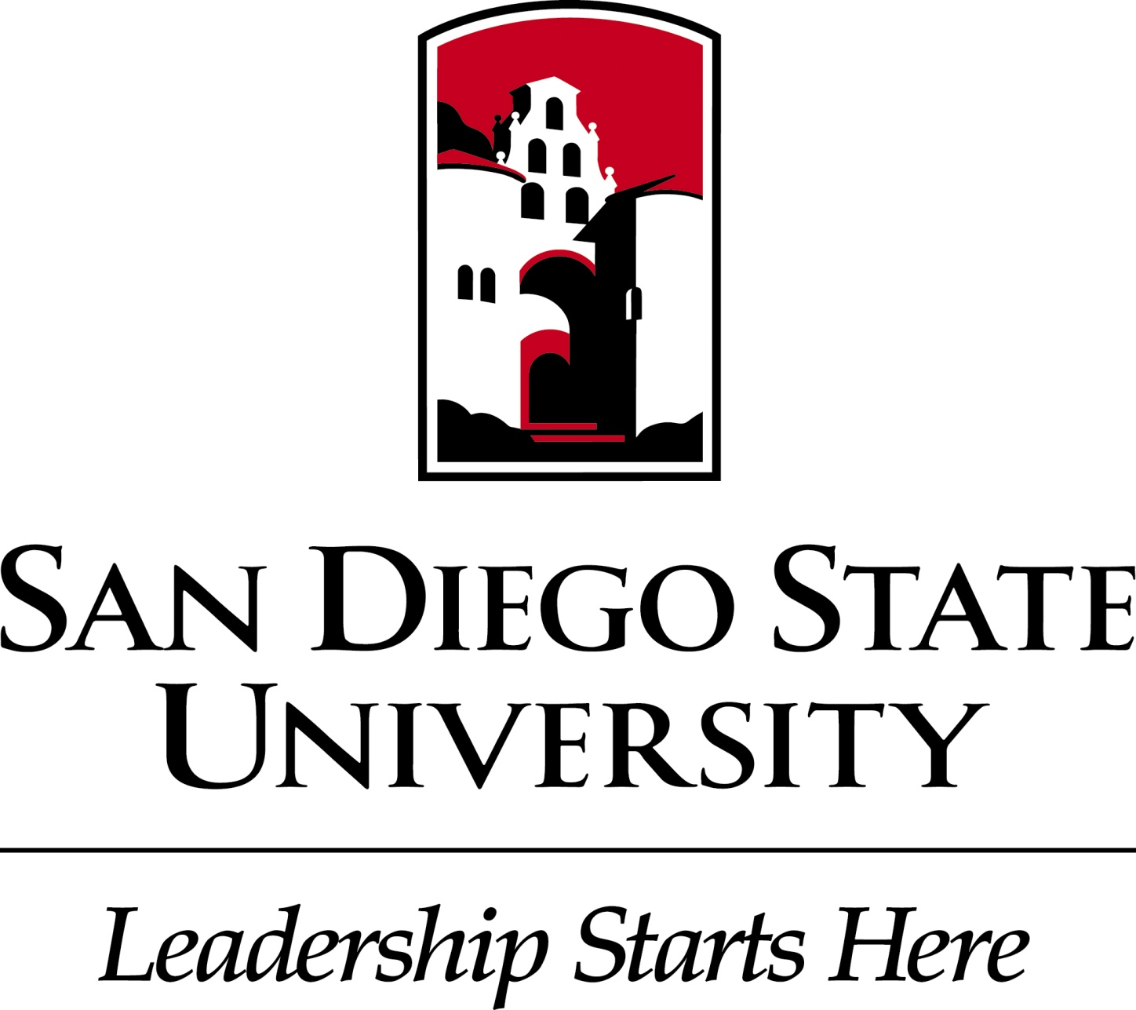

MIS 750 – Strategic Project Management

Spring 2017

03/08/2017 – PMO Proposal

Professor: Dr. Murray E. Jennex, P.E., CISSP, CSSLP, PMP

Alessandro Vomero

ID #821003593

**Assignment 1: Charter Document for PMO Initiative**

**San Diego State University, PMO proposal**

**Section I – Introduction**

The purpose of this PMO is the creation of value through the use of Strategic tools. Using some management analysis tools, it will be shown how it is possible to: stabilize leadership positions, gain the strategic position in other contests and create value reviewing and modifying (basically changing) some internal balances in a more strategic way.

**Section II – Company/Organization Description**

1. **Company/Organization Overview (size, products, mission, goals, strategy, etc.)**
   1. **Size**
      1. Locations:
         1. San Diego, 5500 Campanile Drive, San Diego, CA 92182
            1. Subscription: 33778 (2016)
            2. Acceptance rate: 34.2%
         2. Imperial Valley, 720 Heber Ave, Calexico, CA 92231
            1. Subscriptions: 778 (2012)
            2. Acceptance rate: 44%
      2. Noteworthy items:
         * 1. *Research*: SDSU researchers continue to be among the most productive in the nation, securing 799 research grants and contracts worth nearly $130 million during the last fiscal year.
           2. *Study abroad:* SDSU ranks No. 15 among universities nationwide for students studying abroad as part of their college experience.
           3. *Diversity:* SDSU ranks seventh in the nation for ethnically diversity, according to U.S. News and World Report.
           4. *Fulbright scholars:* SDSU has more student Fulbright recipients than any other California State University and is tied with UCLA for third in California behind Stanford and UC Berkeley.
      3. Student Population
         * 1. Total enrollment: 35,000
           2. Undergraduate enrollment: 30,000
           3. Graduate enrollment: 5,000
           4. 100+ countries represented
      4. Admitted Student Profile Fall 2016
         1. Freshmen
            1. Average high school GPA: 3.85
            2. Average SAT score: 1174
            3. Average ACT score: 27
   2. **Products**: Provide well balanced, high quality education for undergraduate and graduate. Besides, provide several additional services to students and community such as events, research, start-up incubator and fitness activities.
      * 1. Programs offered:
           1. nearly 160 undergraduate majors and minors
           2. 16 pre-professional programs
           3. nearly 100 graduate degrees and credentials
           4. lifelong learning classes, seminars, and certificate programs through the College of Extended Studies
        2. Student Life and Activities
           1. Student organizations: 350+
           2. Greek life: 50+ fraternities and sororities
           3. Athletics: 18 NCAA Division I teams
           4. Study abroad: 335 programs
           5. ROTC: Army, Navy, and Air Force programs
           6. Community service: SDSU students volunteer tens of thousands of hours each year
           7. Major events of the city and region in terms of quality and
   3. **Mission**:
      1. The mission of San Diego State University is to provide well balanced, high quality education for undergraduate and graduate students, and to contribute to knowledge and the solution of problems through excellence and distinction in teaching, research, and service.
   4. **Goals**:

San Diego State University will continue to build its distinctive profile as a dynamic

community of diverse, high-quality, and innovative scholars and artists with local,

national, and international. impact and influence.This final strategic plan presents three broad institutional Goals with specific Initiatives for the next 36-48 months. Areas of investment of financial resources as well as mechanisms to assess success are presented as appropriate.

* + 1. *Area:* ***Cost Reduction.***

As well known, the San Diego State University, is considered one of the best University in the country for the ratio of education and it cost. To maintain this strategic position of Cost Leader, is crucial for the improvement of the offered service: to highest rated education possible with lower costs.

* + 1. *Area:* ***Student Success.***

Goal: San Diego State University will continue to focus on Student Success by emphasizing high-impact practices that produce transformational educational experiences and by fostering an institutional culture that recognizes and rewards student achievement.

Completed and Active projects:

Increase tenured/tenure-track faculty and staff levels to meet critical and strategic needs by investing significant resources over three years.

Create Writing and Math Centers by investing in faculty, graduate assistants and support staff resources, with each Center directed by a tenured/tenure-track faculty member.

Invest funds to increase the four-year graduation rates of all students and eliminate the achievement gaps of under-represented students.

Invest funds to increase the recruitment and retention of under-represented students through targeted recruitment and outreach to inform students of exceptional programmatic and co-curricular opportunities.

Invest in the recruitment and retention of under-represented faculty and staff through targeted activities.

Promote commuter student success based on results of an in-progress needs assessment by the Divisions of Student Affairs and Academic Affairs, with relevant support and resources and in association with the established Commuter Student Lounge of the Aztec Student Union.

Provide focused interventions for at-risk local first-time freshmen in order to increase continuation rates and four- and six-year graduation rates.

Provide diverse educational experiences for all students by leveraging our campus’s rich diversity.

Integrate diversity initiatives in support of these goals.

Provide funding to continue the Aztec Nights program in support of student well-being.

Convene a cross-divisional task force to review, assess, and implement additional support for programs addressing the negative academic and personal consequences of abuse of alcohol and other drugs.

Convene a broad-based task force of faculty and staff to evaluate approaches to integrating learning analytics and the student information system to allow timely interventions that promote student success at course and curricular scales.

Invest funds to staff an LGBT Center, develop programs and fund related academic initiatives.

*Performance Analysis Measures for Student Success Goal:*

* Improved Four- and Six-Year Graduation Rates
* Improved Retention Rates
* Decreased Time to Degree
* Elimination of Achievement Gaps in Graduation Rates
* Growth in Student Honors and Achievements
* Increased Diversification of Faculty and Staff
  + 1. *Area:* ***Research and Creative Endeavors.***

Goal: San Diego State University will continue to enhance its research and creative endeavors profile, with particular emphasis on building areas of excellence and addressing national and international challenges.

Completed and active projects:

Establish a University Honors College with a goal of 1,200-1,400 students from diverse backgrounds through funding of an Associate Director and additional honors courses.

Support the Honors College fundraising goal of a $10-million-dollar endowment for student scholarships and faculty stipends.

Strengthen internship and mentoring programs to foster students’ professional development by working collaboratively with our alumni to create an alumni network that supports lifelong success for all alumni (see further information regarding an Alumni Coordinator in the Engage our Alumni and Community Supporters section).

Increase the rate of undergraduate student participation in approved international experiences to 30% within five years by providing funds for support services.

Expand opportunities for undergraduate scholarship through innovative courses, experiences, and engagement (see further information regarding the Student Research Symposium in the Reinforce the Value of Research for Student Success section).

Support the university’s entrepreneurial centers to enhance students’ entrepreneurial initiatives (see further information in the Contribute to the Advancement of the San Diego Region section).

*Performance Analysis Measures for Community and Communication Goal:*

* Increased Research Expenditures
* Larger Research Endowment
* Greater Number of Undergraduate Students Involved in Research
* Greater Number of Undergraduate Students Involved in Entrepreneurship
* Improved Time to Completion for Master and Doctoral Students
* Positive Trends in Graduate Student Quantitative Metrics of Quality
  + 1. *Area 3****: Community and Communication.***

Goal: San Diego State University will become a center of community life and engagement for students, faculty, staff, alumni, and the public through events, activities, and communication designed to bring diverse participants together.

Completed and active projects:

Increase institutional commitment to the design, development, assessment, and promotion of high-quality courses, programs and degrees through funding for Instructional Technology Services course designers and faculty-assigned time for participation in the Curriculum Design Institute.

*Performance Analysis Measures for Community and Communication Goal:*

* Significant Increases in Favorable Media Coverage of SDSU
* Surveys Showing SDSU is a Great Place to Work
* Increased Membership and Giving of Alumni
* Greater Number of Licenses
* Positive Trends in Royalties
  + 1. *Area 4****: Diversity***

*Goal:* The main purpose of this strategic are is to promote both the recruitment and retention of underrepresented students and of a diverse faculty staff. On the other hand, using initiatives the purpose is to create a cultural competency that is universally recognized as a value and a university priority too.

* + 1. *Area 5****: Internationalization***

*Goal:* For a strategic point of view, it is inevitable to make and pursue plans in terms of internationalization. SDSU put this area as strategic because its diversity culture showed how important and prestigious is to have an effective international students body. Besides, internationalization means also to give the opportunity to students to internationalize their career. Internationalization starts during the college years and even before, therefore, it is crucial to grow in a international environment.

* 1. **Strategy**:

Each goal is composed by several initiatives in head of each goal there are **TASK FORCES** that identify goals and initiatives to pursue. There are **5 TASK FORCES**. For an implementation stand point there are working groups that are cross-divisional groups. They will support the attainment of a number of the goals outlined in the plan.

Initiatives are grouped as:

* + 1. ***Cost Reduction***
    2. ***Student Success:*** 
       1. Promote Student Success Across the University
       2. Enhance Transformational Educational Experiences
       3. Pursue Pedagogical Innovation through Faculty Support
    3. ***Research and creative endeavors:***
       1. Foster the Development and Growth of Excellence in Research and Creative Endeavors
       2. Enhance Creative Arts on Campus
       3. Reinforce the Value of Research for Student Success
    4. ***Community and Communication:***
       1. Engage our Alumni and Community Supporters
       2. Enhance the Campus Environment to Support Faculty & Staff
       3. Contribute to the Advancement of the San Diego Region
       4. Enhance Communication to Raise Awareness of our Excellence
    5. ***Diversity***

The Diversity Strategic goal and its respective task force will be responsible for identifying goals and initiatives the university should undertake in this area, determining the resource requirements of the goals and initiatives, and setting priorities among the recommended goals and initiatives.

* + 1. ***Internationalization***

The Internationalization Strategic goal and its Task Force task force will be responsible for identifying goals and initiatives the university should undertake in this area, determining the resource requirements of the goals and initiatives, and setting priorities among the recommended goals and initiatives.

1. **Company Competitive Position (show on quadrant diagram, use Porter, Value Chain, etc. for analysis)**
   1. **Quadrant diagram**
      1. **Project Planning Grid**
         1. Strategic impact of current systems
            1. High
            2. Low
         2. Strategic impact of a system development portfolio
            1. High
            2. Low

Due to the complex structure of the university we can consider at least two different dimension of competitivity environment. The distinguish is important to align better the projects to the strategy.

* From an **educational, students** attractivity stand point we can consider the San Diego State University a **Turnaround** company: high strategic impact of a system development portfolio, low strategic impact of current systems.
* From a **Cost** stand point, it is considered a **Strategic Company**, (it is well known that the SDSU is a Cost Leader Company), are on track with our strategic position and just need to continue staying competitive, projects are vital to the organization
  1. **Value chain:** in a service industry as a university the value chain does not fit perfectly, but there is possible a reinterpretation of the value chain to use the value chain in a service industry. Therefore, observations are worth mentioning:

Each stage is essentially a value chain in itself delivering value (though supplementary) to the customer. Consequently, inbound logistic, operations, outbound logistics and service form a product in themselves.

**Primary activity**

* + 1. Inbound Logistic: Selection criteria and picking of the students.
    2. Operations: Education.
    3. Outbound Operations: Projection and connection of the students in the work world.
    4. Marketing and Sales: creation of alumni centers.
    5. Services: different services than education.

**Support Services (line)**

* + - * 1. Personnel management
        2. Housing service
        3. Other services
        4. Information systems
        5. Administration services
        6. Scientific research, Research Foundation

1. **Company Needs/Types of Projects (show consistent with company position, use SWOT, Balanced Scorecard, Porter, etc. for analysis)**
   1. **SWOT**: The overarching goal of the San Diego State University is to be ranked among the national leaders in research and education. To achieve this, the SDSU has identified a number of areas that they feel will propel them:
      1. **Student Success.**
      2. **Research and creativity endeavors.**
      3. **Community and Communication.**
      4. **Diversity**
      5. **Internationalization**
         1. **Strengths**
            1. Affordable bachelor’s ad masters.
            2. Productive colleges with some outstanding world class researchers.
            3. The [Carnegie Foundation](https://en.wikipedia.org/wiki/The_Carnegie_Foundation_for_the_Advancement_of_Teaching) has designated San Diego State University a "Research University with high research activity," placing it among the top 200 higher education institutions in the country conducting research.
            4. In the 2015–16 fiscal year, the university obtained $130 million in public and private funding—a total of 707 awards—up from $120.6 million the previous fiscal year. The university generates over $2.4 billion annually for the San Diego economy, while 60 percent of SDSU graduates remain in San Diego Wide range of degrees, bachelors, masters and doctoral programs, 190 degree programs.
            5. It is currently ranked in the top 150 national universities.
            6. Named college of business.
            7. The “Aztec proud” campaign raised over 700 million of dollars among over 280000 alumni.
         2. **Weakness**
            1. Some strategic laboratories are not in a good status.
            2. Still not the best University in the San Diego region from an educational stand point
            3. Absence of a working PMO.
            4. Sometime saw as a makeshift university
            5. No bike sharing or in/off campus programs
         3. **Opportunities**
            1. The university soon expects to be classified as "Doctoral/Research-Extensive".
            2. Growing in terms of attraction and qualities of facility once the new engineering structure will be completed.
            3. Improvement of the facilities
            4. Attractivity for the international students, researchers, freshmen and graduate.
         4. **Threats**
            1. A concrete threat could be represented by the presence of high competitive universities such as SDU, UCSD.
            2. To pursue high risk project to reach a strategic position.
            3. Degradation and failure of critical equipment due to no maintenance budget.
            4. Slowdown of the researching processes.
            5. Loss of quality of facility products, such as clean room products, due to construction/relocation.

**Section III PMO Proposal**

1. **Proposed PMO description (organization, level, scope, skills needed, governance, stakeholders, etc.)**
   1. **Scope**

The main objective of this PMO is to **SET STANDARDS in project management**, since a **Governance** already exists and it is represented by the **TASK FORCES** and a **Steering Committee**, it is necessary to improve the standardization of the projects. To define new competences for a PMO efficiency improvement. Besides, the creation of standard, the definition of best practices, knowledge management, the monitoring of the performance to define how closely related are project with the strategy will take part in this implementation.

The main **objectives** this PMO wants to achieve are:

- from a cost reduction stand point is to **extract and apply the knowledge/best practice** to further reduce time and costs in the planning phase. Besides, use the extracted knowledge for further effectivity and efficiency of projects.

- reorganize the rules/relations of the governance and other components of the organizational chart.

- to implement a scoring matrix for a better project evaluation.

- PM training and consulting

-Crisis and Issue/conflict management

-Knowledge management

* 1. **Service provided:** the PMO of the SDSU would provide support to the project manager and the task force/governance, in the improvement of the creation of standards and, therefore, a better alignment with the corporate strategy.

To do this, it is necessary to get/improve the data gathering, data mining for the creation of the standards. And from a PM stand point, to teach them how to use those standards.

* 1. **Skills needed:** 
     1. Project management skills
     2. Project coordinating
     3. Data analysts/architects
     4. Teaching skills
  2. **Governance:** The governance already exists, but so far, its role is just about planning projects in concert with the five task forces. Therefore, it will supervise the working groups and the task forces work for timely intervention during the critical phases of projects.

With the implementation of this PMO, the rule of governance will become:

* Oversight the work of the working groups and task forces
* Control of the value creation and loss
* Evaluation of the risk
  1. **Stakeholders:**
     1. Students (national/international)
     2. Faculty staff
     3. Community (city, region, county)
     4. Professors
     5. Commercial activities
     6. Event organizations
     7. Industries
  2. **Organization:**

From an organizational stand point the hierarchy would be the following:

* + 1. Steering committee
    2. Task forces
    3. Working groups

Level ii and iii can propose projects.

The task forces will oversee the projects planning phase and picking phase since already work in the line of the value chain.

* 1. **Level Scope**

The maturity level is given by different parameters:

*Description and maturity level*

Level of key project management processes. Formal project planning and control systems are managed, Formal Project management data

are managed (3)

Level of major organizational characteristics. Team oriented, Informal training of Project management skills and practices (3)

Key focus areas of the Project management. Systematic and structure project planning and control for individual projects (3)

1. **PMO Strategic Alignment**

The main purpose of this PMO is to create standards in the project proposals, scoring/picking and to create knowledge retaining system.

As the company strategy clearly shows, there are strategic and operative goals. Therefore, the use of a scoring matrix, KPIs would show consistently how the single projects are aligned with the strategy.

1. **PMO Business**

Due to the large amount of project, their variable complexity and expected transversality, the expected benefits due to the PMO implementation will be:

* Creation of standards in project management
* Implementation of a knowledge-capture system to improve the standards, reduce costs.
* Advanced project coordination
* Cost reduction
* Improving the change and innovation management procedures.
* Creation of an Innovation management task force.
* Support the PM in the planning, execution and follow up phase.

1. **PMO Processes**
   1. **Project Proposal Submission**

Projects will be presented and submitted to the Committee, that will decide to pick, prioritize ad or vice versa projects. Recommendations and comments will be provided in the scoring matrix file.

* 1. **Project Selection Process** (a scoring criteria, what the process is)
     1. Each project will be selected, picked, or refused based both on the scoring matrix and the governance decision. That could decide to pick also low-scored projects but with strategic importance.

Therefore, cost reduction projects that will improve or maintain the standards of quality.

* 1. **Project Selection Scoring Criteria**
     1. The Project selection scoring criteria, contained in the Project Score Sheet, are criteria extracted directly from the strategy. Strategic goals and the base for a project evaluation. Besides, it is crucial the function of the PMO for the project selection/picking phase. Over the scoring criteria, the decision it is up to the governance that will decide to pick also low scored projects reputed necessary or essential to achieve goals.
  2. **Project Assessment** 
     1. Metrics
        1. Cost Performance Index
        2. Schedule Perform Index
        3. Number of successful projects
        4. Average Project Score
        5. Number of project on time
        6. Number of project on budget
        7. Percentage of students works in the campus (how many students work in campus)
        8. Percentage of students/workers (how many workers are students)
        9. Project effectiveness
        10. Project efficiency
        11. Improvement of the Exposure time on media/social media, related yearly/monthly average
        12. Increment of international students in bachelor’s and master programs
     2. Reporting

The governance role in this PMO is to manage, select, and pick projects. The work groups are in chief of the reporting during the planning, execution and follow up phase through a GANTT diagram that will shows how if the project is on time and on budget and with the use of the above metrics. The drawing of these reports is made by the PMs that will decide in concert with the governance the cadence.

* 1. **PMO reporting to management**

The PMO will report to the management (steering committee and Task Forces). The PMO will come out every six months with these reports, in objects they will have the generated cash flow in terms of saved money or reduction of costs and how/when it is improving the position of the company in terms of attainment of operative and strategic goals.

* 1. **PMO Change Management**

The creation of a PMO it could be considered as the very first trial to check the change management practice.

First of all, looking at the diversity of the involved stakeholders, the evidence suggests to come out with an **UNPLANNED BEHAVIUOUR STRATEGY,** letting the internal stakeholders know the importance and the added value of this PMO, a cold turkey will probably cause fear and rejection in a substantial organizational transformation.

Because of the complexity of the project, and the type of added value, it will be important to set up a **step-by-step/parallel implementation** using medium short milestones.

The ADKAR model is applicable and explicative to provide important steps for the change implementation:

* Awareness, ensure to the individual to know the reasons of the PMO.
* Desire, promote the PMO application to make the individuals decide to change.
* Knowledge, build up the knowledge and new skills required for the PMO.
* Ability, ensure that individuals are using the new skills.
* Reinforcement, activate systems to ensure proficient workers with the new PMO paradigms.

From a cost stand point, projects which would further reduce costs stabilizing the cost leadership position, will have the priority mark.

* 1. **PMO Innovation Management process**

As the strategy shows, the main purpose is not to be an Innovation leader. However, it is crucial to define how to manage the innovation regarding the desired strategic position:

* Projects to gain a better position for the stakeholder, like consistent social-media campaign, or to improve systematically facilities and procedures are expected, also leveraging on the strength point (quality of education-costs ratio).
* Paradigm shift in innovation will be decomposed and turned in using a parallel implementation method (as this PMO).
* Before the acceptance every innovation project will be scored and valued by the governance, it is crucial to indicate in the project proposal all the expected and hypotheses of the non-expected outcomes.
* Back-out/contingency plans are necessary with the presentation of an innovation project.
* A 6th task force is charge of the innovation, made by one member of each task force. Its main purpose will be the valuation of the innovation presented.

1. **PMO Services** 
   1. The new service, or value that this PMO would add are:
      1. Creation of standards in PM and scheduling support:
         1. With the creation of standards, this PMO want to create an easier way for the PM to write a project. As well known, the timeliness plays and important role in the PM. That means less time in the planning/scheduling phase and less time could mean more efficacy and less costs.
      2. PMO support projects
         1. Crisis support management: Some project could have scheduling, budget or execution problems. The PMO would recognize strategic area of intervention to avoid losses of value.
      3. Creation of an Innovation Management task force.
         1. The importance of innovation is crucial. It is not possible to let it just happen. Therefore, a dedicated task force is in charge to recognize and manage innovations.
      4. PM training
      5. Cost Reduction
      6. Promote the transactional projects
      7. Advanced project coordination
      8. Knowledge management
      9. Support the PM in the planning, execution and follow up phase.

**Section IV Appendices**

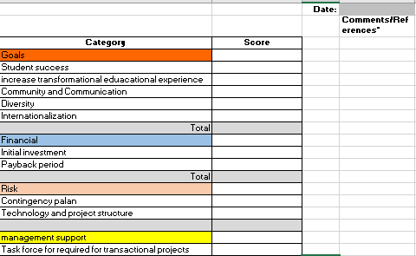

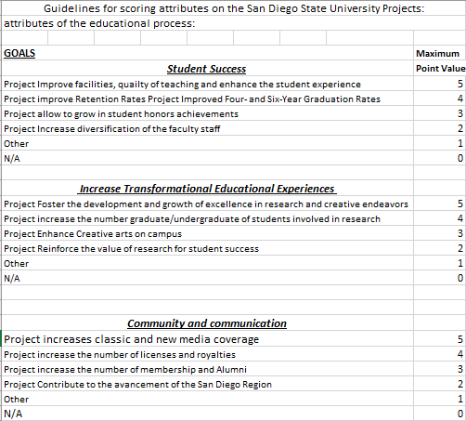

z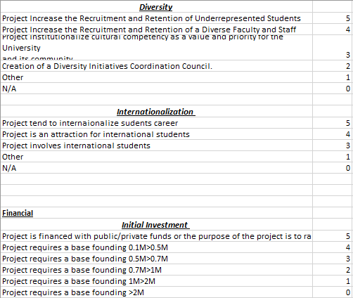

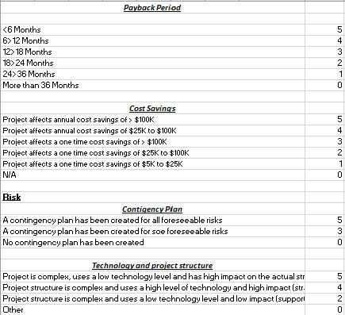

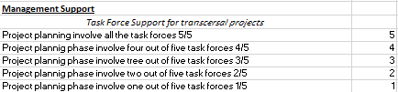

**WRITE UP**

**Question: what did you do?**

As it is said, the good part of the standards is that they give you just indications. Following some standards provided during the lectures, the reading material and some personal research about a PMO, I decided to analyze the strategy of the company in object. Which company pick? Of course, to make things easier I decide to pick the company I used two criteria: a company that I know and a company which have a public strategic plan.

The next step was to extract strategic and operative goals. Of course, they are extracted directly from the strategy, but main problem here was to build scoring criteria that reflects strategic goals and allow the organization a metric that indicate which project is more tied to the strategy. Using some reports and documents from the governance I figured what were priorities and how to score them. Therefore, over the internal/external factors analysis the scoresheet could represent another pillar of the PMO. About this second pillar, I found very useful the knowledge acquired dung the DSS class. This kind of decision could be classified as “Decision Model with many Concurrent Criteria”, and therefore “Some decision involves many criteria that must be applied at the same time”. “This model can be applied for a satisficing or an optimizing decision method”, that actually was part of an assignment and so “easier” to overcome. **(Decision_Modeling, MIS691 fall2016, 12)**

Another issue was to figure the PM level to understand where to operate to add consistent value through a PMO. In that I was helped by personal research about PM levels. Therefore, I decided to put as objective of this PMO the cost/time reduction, the re-organization of the components and rules of the organization.

To understand how to apply the value chain to a complex organization as the one picked for this assignment. To overcome this issues I made several research to come out with a value chain that looked the more appropriate.

**Question: what were the results?**

Provide any printouts produced and answer the thought questions. To improve the score on this section you should also explain what the printouts and questions mean. What are the implications for security? Remember that I value the journey, so take the time to tell me the story and determine the value of your printouts and answers.

Some organization does not recognize the importance of a PMO, especially that organizations which strategy is project-based. The reason is that a PMO, for definition, would give standards and boundaries to the PM, and they prefer way more to feel free to take decision on their own. But with a consistent number of projects it is necessary to have a “Big Picture” of what it is, how is it going and how we would it to be. The purpose of this PMO is to give an order to these projects, to give some standards for the selection. The main reason is to avoid the dissipation of resources (that are scarce and more often over used) in project that are not really tied to the strategy. It is true that a successful project add value, but not in the wanted direction. A better use of resources means more efficiency and effectiveness of the organization, more efficiency and effectiveness mean more success. To have a PMO therefore, is a big added value to the organization that want to be successful. On the other hand, more than often it requires more efforts in change and innovation management. The PMO in itself represent a big change for most of the organizations that decide to adopt this strategic tool. Therefore, to establish better change/innovation culture management is crucial.

**Question: what did you learn?**

A must is represented by a deep analysis of the internal and external factors that could influence the company. Therefore, for a better result in terms of efficiency and effectiveness, it is crucial to make a good SWOT, PESTEL, Five Forces and Value Chain where they are applicable. The reason is that, more than the half of the planning process of a PMO is based on classic elements of analysis of the internal and external factors. To have the “big picture” of a company it is essential to understand what kind of innovation and level intervention the organization needs. And as it is said in the **Change management, Dr. Passenheim, p.2,**  also the analysis of the competitive environment , would give a reason to change: *“A complex structure like an organization is driven by external and internal factors in regard to the need for change. There are a number of external factors that crate the explicit need for change: Market situation or market place, technology, government laws and regulations, economics.”*

The reason behind the decision of an implementation of a PMO is to improve the improve its strategic position, to achieve strategic goals, basically to add value. Value is not just a matter of money. Best practice, knowledge management implementation are other fundamental aspects. A significant aspect of those improvements is performed by the other face of the medal. An implementation of best practice would definitely be translated as cost reduction, effectiveness and efficiency improving, flexibility of the organization. In support this idea I would like to use a cite: “A strong PMO delivers two distinct areas of improvement to the organization. It helps organizations choose the right projects to deliver, and it helps them deliver projects correctly.” Greg Wood, managing director of the corporate PMO for Rio Tinto, a metals and mining corporation and a PMI Global Executive Council member in Brisbane, Australia. **(PMO_Aligning_Strategy_and_Implementation)**

An innovation/change “is too important to just let happen”, but the biggest problem in for the PMO implementation and therefore, with the changing, is to make workers and other organs of the organization to feel the need to change. I think this is probably the hardest thing to do over the implementation.

Another critical passage, as the PM maturity level, is to recognize the Level of PMO that the organization need. The level of a PMO suggest what kind of value is needed, in other words, what the PMO is supposed to do. For the picked organization and the PMO proposed, I would recommend to use a level 3 PMO: define PM methodolody, define skills, risks, staff, PM training and consulting, Knowledge management. **(Night 6 – Levels of a PMO, 11).**